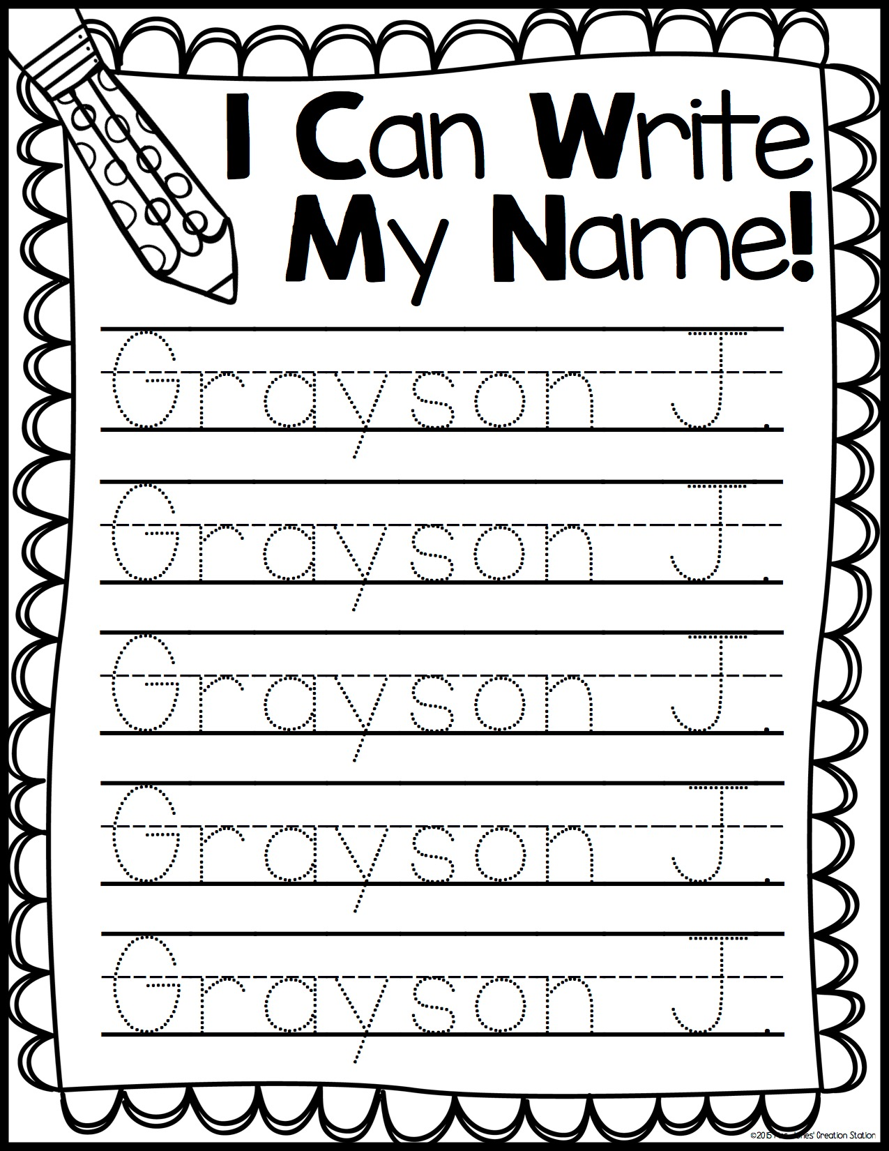

1 1 1 1 1 2 2 2 2 2 3 3 3 3 3 4 4 4 4 4 5 5 5 5 5 6 6 6 6 6 7 7 7 7 7 8 8 8 8 8 9 9 9 9 9

umbers



NAME NAME NAME NAME NAME EDWARD EDWARD EDWARD EDWARD















