Question 1: Construct the right bisector for the segment below. The segment is to scale. Use a ruler. (2 points + 1 for neatness)

Question 2 (8 points +1 for neatness):
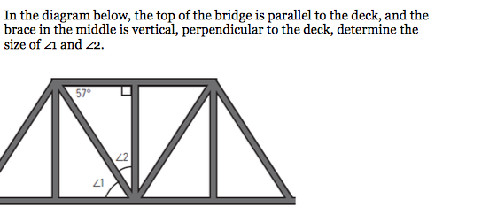

Question 3 (3 points+1 for neatness):

Draw segments so that the circle below contains two supplementary angles, two complementary angles, and one right angle.

Question 4 (8 points+1 for neatness):

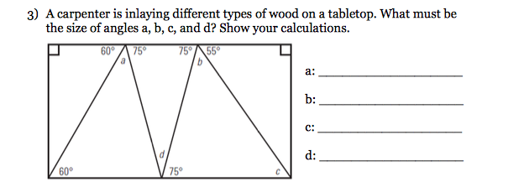

Question 5 (2 points+1 for neatness):
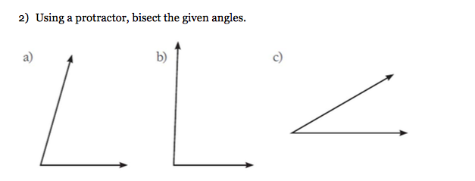

Question 6 (4 points +1 for neatness):
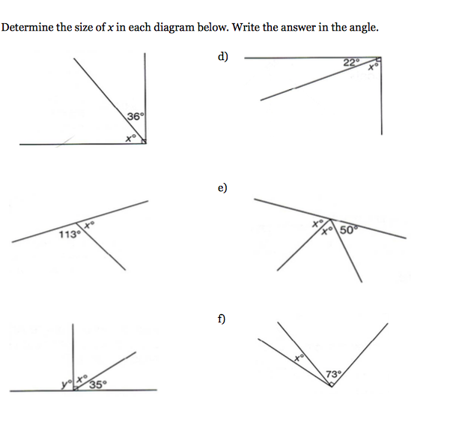

Question 7 (14 points):

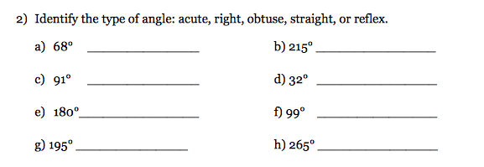

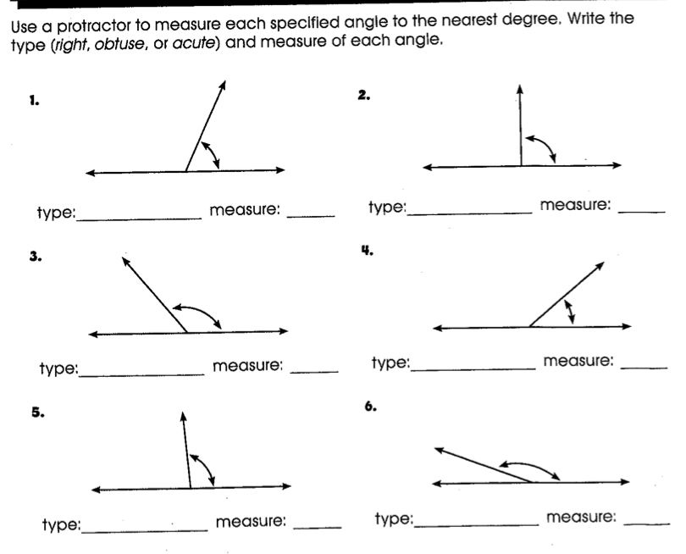

Question 8 (6 points): Name the following figures.

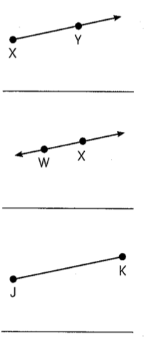
Question 9 (3 points +1 for neatness):

Question 10 (3 points):

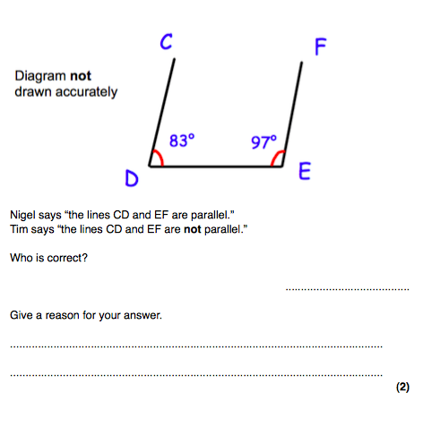
/60

