Question 1 (10 points):

Calculate the area, of the following figure, in the most efficient way possible. Report your final answer in terms of kilometers. Show your work.

Question 2 (10 points):

Calculate the area, of the following figure, in the most efficient way possible. Report your final answer in terms of centimeters. Show your work.

Question 3 (8 points):

Calculate the area, of the following figure, in the most efficient way possible. Show your work.

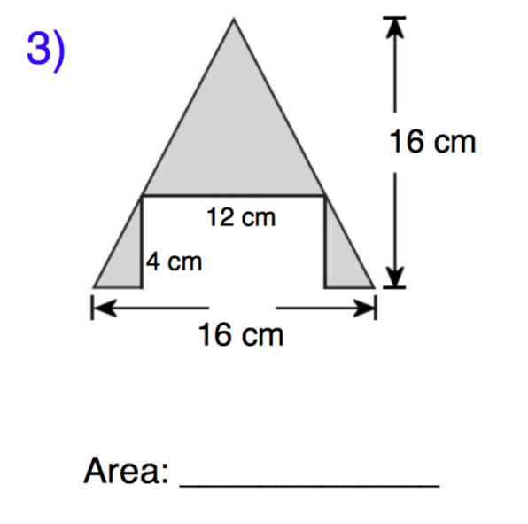

Question 4 (8 points):

What would be the perimeter of a regular octagon if one of the sides measures 528mm? Report your final answer in centimeters. Show your work and explain your reasoning.

