Question 1 (9 points):

Use a ruler and protractor to draw:

- a concave quadrilateral with at least one 45^{O} angle.

- a convex quadrilateral with at least one 45^{O} angle.

- A parallelogram with at least one 90^{O} angle.

Question 2 (4 points):

Identify the type of quadrilateral, find the value of the angle marked with an “x”, and justify how you found the angle.

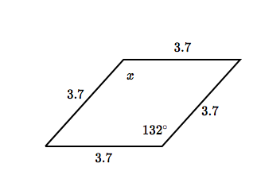

Type of quadrilateral: _________________________ X = __________

Justification: ___________________________________________________________________

Question 3 (4 points):

Identify the type of quadrilateral, find the value of the angle marked with an “x”, and justify how you found the angle.

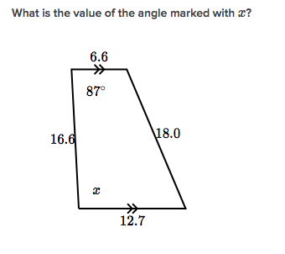
Type of quadrilateral: _________________________ X = __________

Justification: ___________________________________________________________________

Question 4 (4 points):

Identify the type of quadrilateral, find the value of the angle marked with an “x”, and justify how you found the angle.

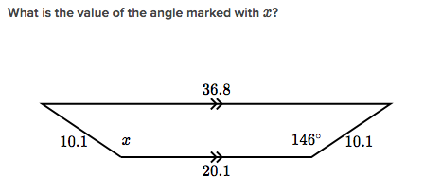
Type of quadrilateral: _________________________ X = __________

Justification: ___________________________________________________________________

Question 5 (3 points):

Draw the diagonals of the figure in Question 4. Justify the statement “the diagonals of the figure, in Question 4, are equal.”

Justification: ___________________________________________________________________

