Question 1 (5 points): Find the missing angles identified by letters (1 point for each angle).

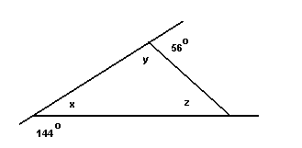

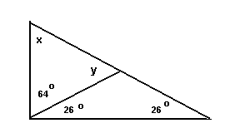

Question 2 (2 points):

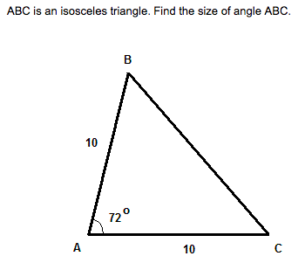

Question 3 (3 points):

Find the angle labled with a “ ? ”

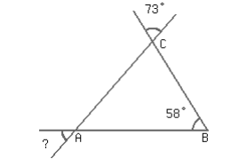

Question 4 (2 points):

Mark the largest angle with an “ X” (on the inside of the triangle). Then, give the name of the largest angle.

Question 5 (4 points):

Draw the three altitudes of this triangle. Label the orthocenter as point O.

Question 6 (4 points):

Draw the three medians of this triangle. Label the center of gravity as point O.

Question 7 (5 points):

Draw the three right bisectors of this triangle. Then, draw the circle which circumscribes the triangle. Use a protractor and a compass.

Question 8 (5 points):

Draw the three angle bisectors of this triangle. Then, draw the circle which is inscribed in the triangle. Use a protractor and a compass.

Question 9 (10 points + 2 for neatness):

Construct the following triangles.

- $m\overline{AB}=6cm, m\overline{AC}=3cm, m\overline{BC}=4.5cm$

- $m\overline{AC}=3.8cm, m<A=35°, m<B=80°$

Question 10 (6 points):

State two things wrong with this triangle. Change the measurements to values that could be true (diagram not to scale).

65^{O}

6cm
22cm

60^{O}
70^{O}
15cm

1)

2)

Question 11 (12 points):

Give each triangle it’s two special names (taking into account the angles and sides).
Diagrams are not to scale but are in proportion within 0.5cm.

/58

